

System Development of

Axle Load Database System

Requirement Specification Document

DataSoft Systems Bangladesh Limited

Requirement Specification Document

System Development of Axle load Database System

Table of Contents

1. Introduction 5

1.1 Purpose of the System Requirement Definition Document 5

1.2 Scope of the Axle Load Database System 5

1.3 Definitions, Acronyms, and Abbreviations 5

1.4 References 5

2. Business Requirements 6

2.1 Business Objectives 6

2.2 Stakeholder Identification and Analysis 6

2.3 Current System Overview 6

2.4 Business Constraints and Assumptions 7

3. Functional Requirements 7

3.1 System Overview 7

3.2 Use Case Descriptions 8

3.2.1 User Registration and Authentication 8

3.2.2 Axle Load Data Collection 8

3.2.3 Database Management 8

3.2.4 Data Analysis and Reporting 9

3.3 System Interfaces 9

3.3.1 User Interfaces 9

3.3.2 Hardware Interfaces 9

3.3.3 Software Interfaces 9

3.4 Data Requirements 9

3.4.1 Types and Structure of Data 9

3.4.2 Data Input and Output 10

3.5 Security Requirements 10

3.5.1 Access Control 10

3.5.2 Data Encryption 10

3.6 Data Transmission 10

3.6.1 Axle Load Data (Daily) 11

3.6.2 Axle Load Data (Live) 11

3.7 System backup (Database backup) 11

3.8 System monitoring and operation 11

4. Non-Functional Requirements 11

4.1 Performance Requirements 11

4.1.1 Response Time 11

4.1.2 Throughput 11

4.2 Reliability and Availability 12

4.3 Scalability 12

4.4 Usability and User Experience 12

4.5 System Maintainability 12

4.6 Legal and Regulatory Requirements 12

5. Constraints 12

5.1 Technical Constraints 12

5.2 Budgetary Constraints 12

5.3 Time Constraints 13

6. Assumptions 13

6.1 Project Assumptions 13

6.2 Environmental Assumptions 13

7. Dependencies 14

7.1 External Dependencies 14

7.2 Internal Dependencies 14

8. Acceptance Criteria 14

8.1 Functional Requirements Acceptance Criteria 14

8.2 Non-Functional Requirements Acceptance Criteria 14

9. Risk Analysis 15

9.1 Identification of Risks 15

9.2 Risk Assessment 15

9.3 Mitigation Strategies 15

10. Glossary 16

10.1 Definitions of Key Terms 16

10.2 Acronyms and Abbreviations 16

11. Appendices 16

11.1 Supporting Documentation 16

11.2 Additional Information 17

Revision History

|  |  |  |  |
| --- | --- | --- | --- |
| Date of Release | Prepared By | Reviewed By | Reference Document |
| 10 Jan 2024 | Mahmudul Hasan Sarker | Muhammad Sajjad Hossain | 03_20230929_TOR for system dev of the ALCS DB system |

# Introduction

## 1.1 Purpose of the System Requirement Definition Document

The purpose of the System Requirement Definition Document is to provide a comprehensive and detailed outline of the objectives, scope, and specifications for the development of the Axle Load Database System. This document aims to clearly articulate the business requirements, functional and non-functional specifications, constraints, and assumptions governing the system's design and implementation. By establishing a common understanding among stakeholders, the System requirement definition acts as a crucial communication tool that aligns the project team toward a shared vision and facilitates the subsequent stages of system development, testing, and implementation.

## 1.2 Scope of the Axle Load Database System

The Axle Load Database System aims to centralize the management of axle load data from various Axle Load Control Stations (ALCS) across Bangladesh. Scope of work of this project will contains design and development of Database and Web-Api to receive data from each ALCS. A web-based reporting will also be developed to monitor and manage received information. List of items to be developed are:

* Database
* Web-Api
* Web Panel

## 1.3 Definitions, Acronyms, and Abbreviations

ALCS: Axle Load Control Station

RHD: Road and Highway Department

FTP: File Transfer Protocol

CSV: Comma Separated value

BRTA: Bangladesh Road Transport Authority

## 1.4 References

Terms of Reference (TOR) for the Axle Load Database System.

# Business Requirements and System overview

## 2.1 Business Objectives

The primary business objective is to enhance the efficiency of managing and controlling overloaded vehicles by aggregating daily axle load data centrally at the RHD Headquarters. This system aims to improve road safety and support informed decision-making for road planning and maintenance.

## 2.2 Stakeholder Identification and Analysis

Stakeholders include RHD and regulatory authorities. A thorough analysis of their needs and expectations will guide the system development.

## 2.3 Current System Overview

RHD oversees the management of all Axle Load Control Stations (ALCS) strategically positioned in Bangladesh along national highways. These ALCS play a critical role in measuring the axle load of vehicles suspected of being overloaded. However, the operation and management of these stations have been outsourced to a private company, serving as the service provider. At the ALCS, penalties are imposed based on the excess weight of vehicles, and the collected penalty fees are reported back to RHD Division offices by the service providers. Currently, the axle load data measured at the ALCS is solely aggregated within the private company and is not transmitted to the RHD headquarters. The project's requirement is to aggregate and accumulate the measured axle load data from each ALCS at the RHD headquarters for centralized monitoring and utilization.

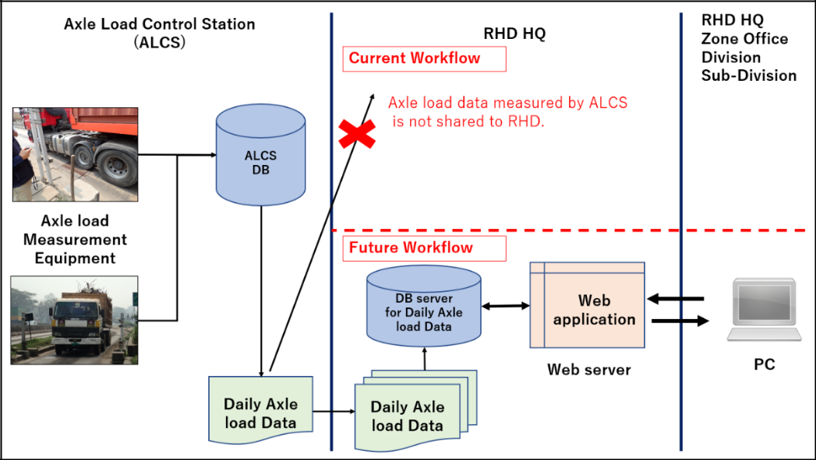

Figure 2.3.1 Work flow image of Axle load database system

## 2.4 Business Constraints and Assumptions

Constraints include time constraints. Assumptions involve the availability of necessary resources and stakeholder cooperation.

## 2.5 System overview

The architecture of the Axle Load System is designed to facilitate secure and efficient management of axle load data. In the below figure Axle Load Control Systems (ALCS) devices securely upload data to the Axle Load System Database through a developed communication module, ensuring a robust and protected data transfer process. This is achieved via a secured Web-API, employing assigned authentication keys to guarantee that only authorized data is transferred and stored on the Axle Load Database System. Users can securely access ALCS information through monitoring panels. The system ensures secure access via HTTPS, allowing an admin user to modify access keys for each ALCS as needed. Real-time API functionalities enable the swift transfer of real-time data to the database, while a batch process facilitates the daily transfer of axle load data files, such as CSV or JSON, from ALCS to the Axle Load Database System. This automated and streamlined process, ensures the seamless integration of daily data into the Axle Load System Database System, adhering to a predefined format and promoting efficient data flow for comprehensive analysis and management. The ALCS Devices will securely upload axle load data to the Axle Load System Database. A secure connection will be developed as a communication module for database communication. Axle Load Control Systems will upload data through the Web-API using assigned authentication keys. Authentication ensures that only authorized data is transferred to the database. The uploaded data will be stored on the Axle Load System DB Server. RHD-authorized users can access ALCS information through a secure monitoring panel. The system will be accessed securely through HTTP with a security key. Each ALCS is assigned a designated key that can be modified by an admin user, and access can be halted if necessary. A real-time API facilitates the transfer of real-time data to the Axle Load System Database. Daily axle load data is recorded, extracted from each weigh station's database, and converted into a daily data transmission format file (e.g., CSV, JSON File). The file is then distributed to ALCS terminals for processing. A batch Process makes it easy to send a file from ALCS to the Axle Load System Database using the FTP command. Every day, data files like CSV or JSON from ALCS will be added to the Axle Load System Database, following a specific format. Real-time communication ensures seamless and efficient data flow from ALCS to the Center Server Area DB server. Automation through a function or scheduler function streamlines this process.

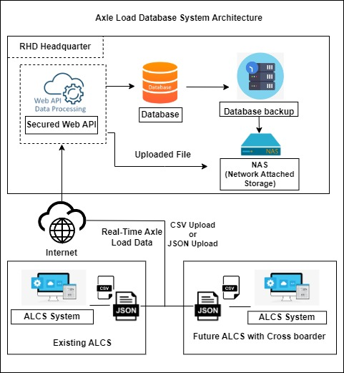

Figure 2.5.1: Axle Load Database System and Data Flow Architecture

## 2.6 Use Case Descriptions

### 2.6.1 User Registration and Authentication

The User Registration and Authentication use case involves the process by which authorized users **can create other users** on the Axle Load Database System**.** **With created access it** ensures a secure and controlled user environment. **Access of users can be changed or halted by administrator.**

### 2.6.2 Axle Load Data Collection

The Axle Load Data Collection use case focuses on the systematic collection of axle load data from Axle Load Control Stations (ALCS) distributed across specific locations. This ensures a centralized repository of accurate and timely data for further analysis.

### 2.6.3 Database Management

The Database Management use case involves the administrative tasks related to the management and control of the Axle Load System Database. This ensures the system operates with current and secure information, data is stored in optimized and securely and information is accessible based on need.

### 2.6.4 Data Analysis and Reporting

The Data Analysis and Reporting use case involves the generation of reports based on the axle load data that’s received and stored in the Axle Load System Database. This provides users with meaningful insights for informed decision-making by providing reports on received information.

2.6.5 Use case diagram

The Use Case Diagram for the Axle Load Database System is shown below. Each Axle Load Control Station (ALCS) is linked to the WebAPI using a unique Authentication Key. Axle load data is stored in the database through batch processing. Only authorized users by the Road and Highway Department (RHD) can access the monitoring panel to view the axle load data.

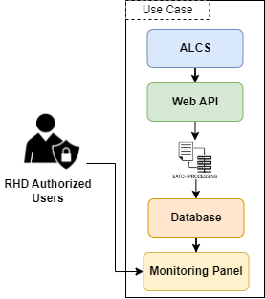

Figure 2.6.5.1: Axle load database system Use Case Diagram

# Functional Requirements

## 3.1 System function list

## 3.2 System Interfaces

The Axle Load Database System incorporates various interfaces to facilitate user interaction, hardware connectivity, and software integration.

### 3.2.1 User Interfaces

The user interfaces are designed to provide an intuitive and user-friendly interaction platform. Administrative users at the RHD headquarters and branch users can access the system through secure web-based monitoring panels. These interfaces enable users to perform tasks such as user registration, authentication and reporting. The user interfaces prioritize clarity and ease of use, ensuring efficient navigation and interaction with the system functionalities.

Web-Api enables interfacing with other ALCS to receive daily axle load data. It enables secure data connection to collect daily and live data.

### 3.2.2 Hardware Interfaces

Hardware interfaces establish connections between the software system and the physical components involved. In the context of the Axle Load Database System, hardware interfaces include communication links with Axle Load Control Stations (ALCS) with Axle Load Database System Central Server. Also, hardware interface between various servers like web-server, database-server and NAS. These interfaces enable secure data upload from ALCS stations to the Axle Load System Database System. The hardware interfaces ensure reliable and efficient communication, supporting the seamless transfer of axle load data from the field to the central database.

### 3.2.3 Software Interfaces

Software interfaces are crucial for the integration of the Axle Load Database System with other software components. The system employs a secure communication module including a Web-API to facilitate data transfer between ALCS and the Axle Load System. This Web-API ensures that only authenticated data accompanied by assigned keys is transmitted and enhancing the overall security of the system. A real-time APIs are utilized for the swift transfer of real-time data, contributing to the system's responsiveness. Web platform enables visual reporting on the received data. These software interfaces are designed to support data exchange in various formats, such as CSV or JSON, ensuring compatibility and flexibility in handling diverse data sources and formats.

## 3.3 Data Requirements

The data requirements of the Axle Load Database System are structured to efficiently manage and analyze various types of information related to axle loads.

### 3.3.1 Types and Structure of Data

The system organizes data into different types to make it well-organized and easy to find. These may types include security information about access controls, authentication keys, and user management for keeping the system secure. There are also configuration data tables that cover things like types of vehicles, load management and details about Axle Load Control Stations (ALCS). Basic information data tables contain essential details about the system, such as information on vehicle types and load management. Axle Load Data Tables store comprehensive records of axle load data, including daily and real-time measurements, enforcement information, and transactional data. This structured approach ensures that the data is easily accessible and serves its intended purposes effectively.

### 3.3.2 Data Input and Output

The data input process involves ALCS devices securely uploading axle load data to the Axle Load System Database. This data transfer occurs through a Web-API using assigned authentication keys, ensuring that only authorized and authenticated data is transmitted. The uploaded data, including daily axle load measurements, enforcement information, and transactional data, is stored on the Axle Load System DB Server.

Data output is designed to support reporting and decision-making. The system generates outputs in the form of reports, allowing users to gain insights into received data. The structured data output is aimed at facilitating informed decision-making, contributing to road planning, and enhancing overall overload control within the Roads and Highways Department (RHD).

## 3.6 Data Transmission

Data transmission in the Axle Load Database System is a critical aspect, involving the secure and efficient transfer of axle load data from ALCS devices to the central database.

### 3.6.1 Axle Load Data (Daily)

Daily axle load data recorded throughout the day at various weigh stations is extracted from the weigh station databases. This data is then consolidated into a specific data transmission format file, such as CSV or JSON. The file is then transferred to Axle Load Database System. This process is automated through functions or scheduler functions ensuring a systematic, efficient and secure flow of daily axle load data from ALCS to the central database for further analysis and management.

### 3.6.2 Axle Load Data (Live)

For real-time data, a real-time API is employed to facilitate the immediate transfer of data to the Axle Load Database System. This ensures that live axle load data is continuously fed into the system, allowing for instantaneous updates and analysis. The real-time communication process is designed to be seamless and efficient, contributing to the system's responsiveness in monitoring and managing axle load data.

# Non-Functional Requirements

Non-functional requirements focus on aspects beyond specific functionalities, addressing factors crucial for the system's overall performance, reliability, scalability, usability, maintainability, and compliance with legal and regulatory standards.

## 4.1 Performance Requirements

### 4.1.1 Response Time

The Axle Load Database System is designed to meet stringent response time requirements. Users including administrators and other stakeholders can expect swift and efficient responses from the system, ensuring a seamless and responsive user experience.

### 4.1.2 Throughput

The system's throughput, reflecting the rate of data processing and transfer is optimized to handle a substantial volume of axle load data efficiently. This ensures that data from Axle Load Control Stations (ALCS) is processed and aggregated in a timely manner, supporting real-time decision-making.

## 4.2 Reliability and Availability

The system places a high premium on reliability and availability. To ensure consistent performance, the system undergoes rigorous testing for stability and resilience. The architecture includes redundancy measures, minimizing the risk of system failures and enhancing overall reliability. Additionally, the system is designed to maximize uptime, ensuring that stakeholders have continuous access to crucial axle load data.

## 4.3 Scalability

Scalability is a key consideration to accommodate potential growth in data volume and system users. The architecture is designed to scale seamlessly, allowing the system to handle increased data loads, additional users, and evolving requirements without compromising performance. This scalability ensures the long-term viability of the Axle Load Database System.

## 4.4 Usability and User Experience

Usability and user experience are prioritized to ensure that stakeholders, including administrators and other users, can interact with the system intuitively and efficiently. The user interfaces are designed with a user-centric approach, promoting ease of navigation and minimizing the learning curve. This enhances user satisfaction and fosters effective utilization of the system.

## 4.5 System Maintainability

Maintainability is a critical aspect for the longevity and adaptability of the system. The architecture and codebase are structured to facilitate ease of maintenance, updates, and modifications. Regular maintenance tasks, including database backups and system monitoring are streamlined to minimize the administrative burden and ensure the continued reliability of the system.

## 4.6 Legal and Regulatory Requirements

Adherence to legal and regulatory standards is paramount. The Axle Load Database System is developed in compliance with relevant laws and regulations governing data security, privacy and transportation. The system includes features and measures to ensure that axle load data is handled responsibly and in accordance with applicable legal frameworks, safeguarding the system's integrity and legal standing.

## 4.7 Security Requirements

The security requirements of the Axle Load Database System are paramount to ensure the confidentiality, integrity, and authenticity of the stored data and the communication processes.

### 4.7.1 Access Control

Access control mechanisms are implemented to regulate and manage user interactions with the system. The system employs a hierarchical access control system, allowing administrative users to manage and control various aspects of the system behavior. Access control includes the ability to list Axle Load Control Systems (ALCS), manage authentication keys for uploading data, and oversee user management. This ensures that only authorized personnel with the appropriate privileges can access and modify critical components of the system, enhancing overall data security.

### 4.7.2 Data Encryption

The Axle Load Database System uses a secure Web-API connection for ALCS to safely send data to the central database with specific encrypted authentication keys. For storing sensitive information data encryption may be applied to prevent unauthorized usage. User’s authentication information should be encrypted as secure information.

## 4.8 System backup (Database backup)

System backup procedures are integral to ensure data safety and facilitate recovery in the event of system failures or data corruption. The Axle Load Database System employs a comprehensive approach to automated database backup.

## 4.9 System monitoring and operation

Efficient system monitoring and operation are critical for ensuring the smooth functionality of the Axle Load Database System. The system incorporates a monitoring panel accessible by authorized users at the RHD headquarters and branch offices.

# Constraints

## 5.1 Technical Constraints

Technical constraints refer to limitations imposed by the available technologies and infrastructure. The Axle Load Database System must operate within the capabilities and constraints of the existing technical environment. This includes compatibility with hardware specifications, software dependencies, and network infrastructure. Any limitations or requirements set by the current technological landscape must be considered in the design and implementation of the system.

## 5.2 Budgetary Constraints

Budgetary constraints highlight the financial limitations that influence the development and deployment of the Axle Load Database System. The project must adhere to a predefined budget, encompassing expenses related to software development, hardware acquisition, system testing, and any other associated costs. The development team must optimize resource allocation to ensure the project's financial sustainability and successful completion within the specified budgetary constraints.

## 5.3 Time Constraints

Time constraints represent the schedule timelines for the development, testing, and deployment of the Axle Load Database System. The project must adhere to predefined schedules, considering deadlines for the completion of different project phases. Time constraints are critical in ensuring timely delivery and deployment of the system to meet the needs of the Roads and Highways Department (RHD) and the Japan International Cooperation Agency (JICA). Efficient project management practices, including milestone tracking and regular progress assessments, are essential to meet these time constraints effectively.

# Assumptions

## 6.1 Project Assumptions

Project assumptions are key considerations that are accepted as true for planning purposes, even though they may not be fully confirmed. In the context of the Axle Load Database System:

1. It is assumed that the hardware and network infrastructure required for the system will be readily available and compatible with the specified technical requirements.
2. The project assumes that the development team will have access to the necessary skills and expertise to design, develop, and deploy the Axle Load Database System successfully.
3. Assumptions include the availability of relevant data from Axle Load Control Stations (ALCS) and that the data conforms to expected formats and standards.
4. The project assumes that there will be no major changes in project scope, requirements, or regulations during the development process.

## 6.2 Environmental Assumptions

Environmental assumptions pertain to the external factors that may impact the project. Assumptions in this category include:

* It is assumed that there will be stable and consistent network connectivity for the secure transmission of data between Axle Load Control Stations (ALCS) and the central database.
* Environmental assumptions include the assumption that the political and regulatory environment in Bangladesh will remain stable and not introduce significant changes affecting the project.
* The project assumes that the Roads and Highways Department (RHD) and the Japan International Cooperation Agency (JICA) will provide necessary support and cooperation throughout the project lifecycle.

# Dependencies

## 7.1 External Dependencies

External dependencies refer to factors outside the project's direct control that can impact its progress. Dependencies in this category include:

1. The project is dependent on the timely provision of data from Axle Load Control Stations (ALCS) for accurate testing and validation of the system.
2. External dependencies include compliance with regulatory standards, and the project is reliant on external entities adhering to these standards.

## 7.2 Internal Dependencies

Internal dependencies are factors within the project's control that are interdependent. Dependencies in this category include:

* The development of the Axle Load Database System is dependent on the successful completion of database design and web API development phases.
* Internal dependencies also encompass the coordination between the development team and RHD users for system testing and validation.

# Acceptance Criteria

## 8.1 Functional Requirements Acceptance Criteria

Functional requirements acceptance criteria establish the conditions that must be met for each functional aspect of the Axle Load Database System to be deemed acceptable:

**User Registration and Authentication:** Acceptance criteria include successful user registration and secure authentication processes, ensuring users can log in securely.

**Axle Load Data Collection:** Criteria involve accurate collection and storage of axle load data from various Axle Load Control Stations (ALCS) in the designated database.

**Database Management:** Acceptance criteria encompass the error-free execution of administrative actions, including security configurations, general information updates, and BRTA information management.

**Reporting:** Criteria involve the generation of accurate reports based on received axle load data, demonstrating the system's reporting capabilities.

**System Interfaces:** Acceptance criteria include seamless navigation, intuitive interactions, and compatibility with existing hardware and software components for user interfaces, hardware interfaces, and software interfaces.

## 8.2 Non-Functional Requirements Acceptance Criteria

Non-functional requirements acceptance criteria set benchmarks for aspects beyond specific functionalities, ensuring the overall quality and performance of the Axle Load Database System:

**Response Time:** It involves response times within acceptable limits for various system operations, ensuring quick and efficient interactions.

**Reliability and Availability:** Acceptance criteria include minimal downtime, consistent performance and successful recovery measures in case of system failures.

**Scalability:** It involves successful handling of growing volumes of data and users without compromising performance, demonstrating the system's scalability.

**Usability and User Experience:** Acceptance criteria include positive user feedback, and efficient interactions, ensuring optimal user experience.

**System Maintainability:** It involves the successful completion of regular maintenance tasks, including streamlined backup procedures, without disruptions.

# Risk Analysis

## 9.1 Identification of Risks

Identifying potential risks is a crucial step in effective risk analysis for the Axle Load Database System:

* Risks include unauthorized access to axle load data, potentially compromising the integrity and confidentiality of the information.
* Risks may arise if there are unforeseen incompatibilities with existing hardware, software, or network infrastructure.
* Risks involve changes in regulatory standards that may impact the system's compliance and functionality.

## 9.2 Risk Assessment

Risk assessment involves evaluating the likelihood and potential impact of identified risks:

1. Data Security Breaches: High impact and moderate likelihood.
2. Technological Compatibility Issues: Moderate impact and low to moderate likelihood.
3. Regulatory Changes: Moderate impact and low likelihood.

## 9.3 Mitigation Strategies

Mitigation strategies are devised to address and minimize the impact of identified risks:

* Implement robust encryption measures, access controls and regular security audits to mitigate the risk of unauthorized access.
* Conduct thorough compatibility testing during the development phase and maintain flexibility for adapting to technological changes.
* Establish a continuous monitoring system for regulatory updates and maintain an agile development approach to swiftly adapt to any changes.

# Glossary

## 10.1 Definitions of Key Terms

**Axle Load Control Stations (ALCS):** These are Axle load system stations located across Bangladesh to measure and monitor the axle load of vehicles, contributing data to the central Axle Load Database System.

**Web-API:** Web Application Programming Interface, it refers to a set of protocols and tools for building software applications and enabling communication between different software systems over the web.

**RHD (Road and Highways Department):** The government agency in Bangladesh responsible for the planning, development, and maintenance of the country's road infrastructure.

**BRTA (Bangladesh Road Transport Authority):** The regulatory authority in Bangladesh overseeing road transport and traffic management, including vehicle registration and licensing.

**FTP (File Transfer Protocol):** A standard network protocol used to transfer files from one host to another over a TCP-based network, such as the internet.

**CSV (Comma-Separated Values):** A plain text file format used to store tabular data, where each line of the file represents a row of the table, and columns are separated by commas.

**JSON (JavaScript Object Notation):** A lightweight data interchange format that is easy for humans to read and write and easy for machines to parse and generate.

## 10.2 Acronyms and Abbreviations

ALCS: Axle Load Control Station

RHD: Road and Highway Department

FTP: File Transfer Protocol

CSV: Comma Separated value

RDBMS: Relational Data Base Management System

DB: Data Base

HTTP: Hypertext Transfer Protocol

BRTA: Bangladesh Road Transport Authority

L2SW: Layer 2 Switch

LAN: Local Area Network

IP: Internet Protocol

# Appendices

## 11.1 Supporting Documentation

N/A

## 11.2 Additional Information

N/A